Full Stack Development with MERN Project Documentation format

# Introduction

**Project Title : LearnHUb:Your Center For Skill Enhancement**

**Team : 1)** V.BHANU SRI

* + 2)T.V.K.PRADEEPTHI

3)T.SANTHI KUMARI

4)U. KRISHNA SIVANI

**Team ID:**LTVIP2025TMID53135

# Project Overview

* + **Purpose:**LearnHub is a modern, minimalist digital learning platform that enables students to enroll in courses, track progress, and receive certificates, while teachers and admins can manage courses and users.
  + **Features:**
* User authentication (student, teacher, admin roles)
* Course browsing, filtering, and enrollment
* Video content delivery with progress tracking
* Certificate generation and download
* Admin dashboard for user and course management
* Responsive, accessible, and cohesive UI

# Architecture

* + **Frontend:**
  + Built with React (Vite, Material-UI)
  + Component-based structure (pages, commonadmin, user, etc.)
  + State management via React Context and hooks
  + Responsive design with modern CSS
  + **Backend:**
  + Node.js with Express.js,
  + RESTful API structure,
  + JWT-based authentication and role-based authorization,
  + Multer for file uploads (videos, thumbnails)
  + **Database:**
* MongoDB (Mongoose ODM)
* Schemas for users, courses,
* enrollments, announcements, etc.
* Relationships: Users ↔ Courses ↔ Enrollments

# Setup Instructions

* + **Prerequisites:**
  + Node.js (v16+ recommended),
  + MongoDB (local or Atlas)
  + Git
  + **Installation:**git clone [your-repo-url],
  + cd code/backend,
  + npm install,
  + cd ../frontend,
  + npm install,

# Folder Structure

* + **Client: Server:**

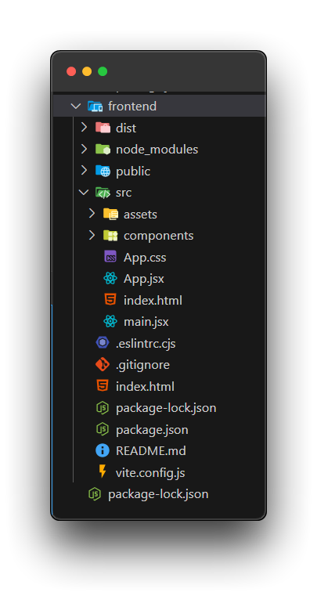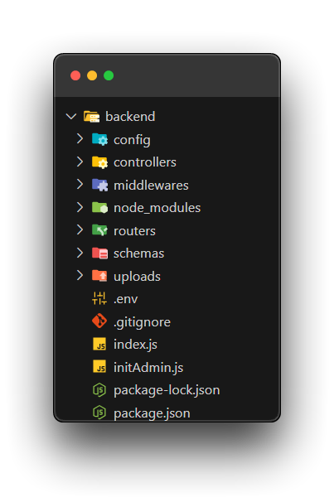

# API Documentation:

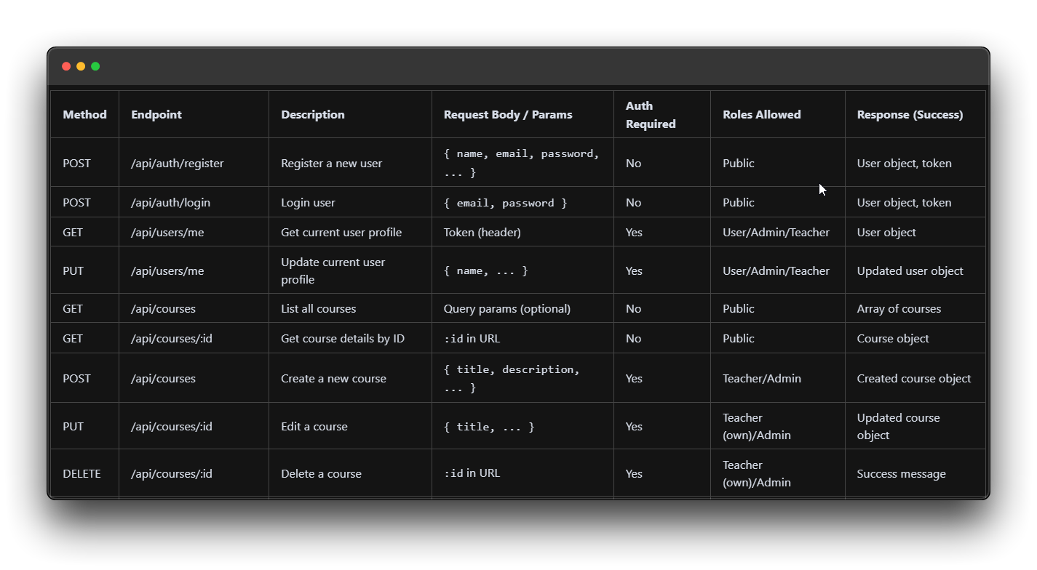

# Authentication

1. JWT tokens issued on login, stored in localStorage.
2. Role-based access (student, teacher, admin).
3. Protected routes via middleware on backend and route guards on frontend.

# User Interface:

# Home Page:

# 

# Registration Form:

# 

# Testing:

# Demo

* + DEMO LINK - <https://drive.google.com/file/d/1sjjk_5GQP281vXkWEBuPwU4wwu5XBg2c/view?usp=sharing>

# Known Issues:

# No real payment gateway (demo only)

# UI layout inconsistencies on some small screens

# Certificate print formatting varies by browser

# FutureEnhancements:

# Integrate real payment gateway (Stripe, Razorpay)

# Add notifications and messaging

# Implement advanced analytics for admins

# Add more media/content types (PDFs, quizzes)

# Improve accessibility and add mo’re automated test